**Oath for Software Engineers**

***"As a responsible software engineer, I pledge to uphold the highest ethical standards in my work. I will:***

1. **Act with Integrity – Ensure honesty, transparency, and fairness in all aspects of software development.**
2. **Prioritize User Safety and Privacy – Protect user data, privacy, and security in software systems.**
3. **Adhere to Professional Standards – Follow industry best practices, legal regulations, and ethical guidelines such as the ACM Code of Ethics and the IEEE Software Engineering Code of Ethics.**
4. **Ensure Quality and Reliability – Develop software that is safe, reliable, and efficient, avoiding negligence or shortcuts that may compromise system integrity.**
5. **Respect Intellectual Property and Avoid Plagiarism – Acknowledge and credit the work of others, ensuring originality in software solutions.**
6. **Practice Social Responsibility – Recognize the societal impact of software and contribute positively to technology development.**
7. **Report Ethical Violations – Speak out against unethical practices and support a culture of accountability and professionalism."**



Signature:

Name / USN: KSHITIJ SINGH / 1NT23IS105

Date: 18-03-25

Place:

Real-world ethical dilemma : Computer screen unlocked at work

Introduction:

In the field of software engineering, data privacy is an ongoing ethical issue, especially with apps that collect personal information. One common dilemma arises when engineers are tasked with developing software that collects sensitive user data, but the business goal is to maximize the use of this data for commercial purposes. This can lead to pressure to gather more data than users are aware of or consent to, which creates a conflict between user privacy and company profits.

In this scenario, the software engineering team is developing a mobile application that collects various personal details, such as location, browsing habits, and potentially even biometric data. Management encourages the engineering team to increase data collection for better-targeted ads, but this may conflict with the ethical principles of transparency and user consent.

Ethical Issues Involved:

The key ethical issues that arise in this scenario include:

1. **Violation of User Privacy**:  
   The app may collect more personal data than necessary, possibly without adequately informing users about the data collection process. This risks breaching user privacy by gathering information that users are not fully aware of or did not explicitly consent to.
2. **Misleading Users**:  
   The app’s privacy policy might not clearly convey how personal data is being collected and used. If users are not made aware of the full scope of data usage, it may be considered misleading or deceptive.
3. **Trust**:  
   Users trust that companies will handle their personal data responsibly. Any breach of this trust, especially if users’ data is sold or used in unintended ways, can significantly harm the relationship between the company and its users.
4. **Pressure from Management**:  
   Software engineers may be under pressure to prioritize the company's financial interests, potentially compromising their professional ethics and responsibilities to protect users' privacy.

Framework: ACM Code of Ethics

The **ACM Code of Ethics** offers important guidance in navigating ethical dilemmas like this one. Key principles that are relevant to this scenario include:

1. **Public Interest (Principle 1.1)**:  
   "Software engineers shall act consistently with the public interest."  
   This principle requires engineers to consider the societal impact of their work. In this case, prioritizing user privacy and ensuring that data collection aligns with user consent and societal norms is crucial.
2. **Honesty and Transparency (Principle 2.5)**:  
   "Software engineers shall not knowingly mislead clients or the public."  
   Transparency about data collection practices is essential. Engineers should ensure that users fully understand what data is being collected and how it will be used, so they can make informed decisions.
3. **Privacy (Principle 1.6)**:  
   "Software engineers shall respect the privacy of others."  
   Respecting privacy means engineers should limit data collection to only what is necessary for the app’s functionality and ensure users are aware of the data collection process.
4. **Accountability (Principle 3.3)**:  
   "Software engineers shall ensure that their products and systems meet the highest standards of quality."  
   Engineers are responsible for making sure that the systems they build are ethical, secure, and respect users' rights. In this context, they should ensure the app complies with privacy regulations and ethical standards.

Analysis:

Ethically, the company’s approach of aggressively increasing data collection raises significant concerns. The absence of clear user consent and the possibility of misleading users regarding how their data will be used violate both transparency and privacy principles. The engineering team, knowing the ethical implications, faces the difficult choice of whether to comply with business objectives or take a stand for user privacy.

If engineers comply with management’s demands, they risk violating user trust and endangering the app’s reputation. However, refusing to comply may mean sacrificing potential profit for the company but ensures that user privacy is respected and that the engineers fulfill their ethical duties.

Proposed Ethical Course of Action:

The following steps represent an ethical course of action based on the principles outlined in the ACM Code of Ethics:

1. **Enhance Transparency**:  
   The engineering team should advocate for the development of clear and transparent privacy policies. These policies should explain precisely what user data is being collected, why it is being collected, and how it will be used. Additionally, the app should provide users with explicit options to consent to data collection, ensuring they are fully aware of what they are agreeing to.
2. **Adopt Data Minimization Practices**:  
   The team should encourage the company to follow data minimization principles, only collecting the data that is strictly necessary for the app’s core functionality. Avoid collecting sensitive personal data unless it is absolutely necessary for the user experience and is explicitly communicated to users.
3. **Provide User Control**:  
   Engineers should implement features that allow users to manage their data. This could include providing a simple way for users to view the data the app collects, delete their data, or opt-out of specific types of data collection.
4. **Push for Ethical Oversight**:  
   If management pressures engineers to overlook privacy concerns, the engineers should escalate the issue to higher management or the company’s ethics committee, if available. If necessary, they should consider refusing to proceed with development until ethical standards are met.
5. **Conduct Regular Audits**:  
   Regular audits of data practices should be implemented to ensure compliance with both legal standards (such as GDPR or CCPA) and ethical guidelines. Having an external party evaluate the app’s data privacy practices could also provide an additional layer of accountability.

Conclusion:

Data privacy is a significant ethical concern in software engineering, and developers must balance the interests of users and companies. The ACM Code of Ethics provides a valuable framework for making decisions that prioritize user privacy, honesty, and transparency. The proposed actions—enhancing transparency, adopting data minimization, providing user control, and advocating for ethical oversight—help ensure that engineers fulfill their responsibility to protect users while still supporting the company’s long-term interests.

**Appendix:**

* **ACM Code of Ethics**:  
  The ACM Code of Ethics outlines the ethical responsibilities of software professionals, particularly focusing on respecting user privacy, maintaining honesty and transparency, and acting in the public interest.
* **Privacy Laws and Regulations**:  
  The General Data Protection Regulation (GDPR) and the California Consumer Privacy Act (CCPA) are significant privacy regulations that govern how companies collect, store, and process user data. These laws enforce transparency and user consent, and non-compliance can result in serious legal consequences.

Ethical Dilemma: Playing Computer Games During Work Hours

Introduction

The use of work time for non-work-related activities, such as playing computer games during work hours, presents an ethical dilemma. This issue is especially relevant in a software engineering context, where a significant amount of time can be spent in front of a computer, making it easy to become distracted. The dilemma raises questions about personal responsibility, professional conduct, and the obligations an employee has towards their employer, team, and customers. In this report, the ethical implications of playing computer games during work hours will be explored using the **ACM Code of Ethics** as a guiding framework, followed by a proposed ethical course of action.

Ethical Issues Involved

The act of playing computer games during work hours can create a variety of ethical issues:

1. **Violation of Professional Responsibility:** Software engineers are expected to dedicate their time to performing work-related tasks that benefit their employer and customers. Playing games during work hours undermines this responsibility and may lead to reduced productivity, resulting in delayed deadlines or suboptimal work outcomes.
2. **Disrespect for Employer’s Trust:** Employers hire employees based on the assumption that they will focus on work during working hours. Playing games can be seen as a breach of that trust, as it indicates that the employee is not fulfilling their duties in a manner expected by their employer.
3. **Impact on Team and Company:** If playing games during work hours becomes a habit for an employee, it could lead to a negative work environment. It may impact the performance of a team, cause delays in project timelines, and eventually affect the company’s bottom line. This is especially critical in software engineering, where collaboration and timely delivery are key to success.
4. **Balance between Work and Personal Time:** While it’s important for employees to have a balance between work and personal life, doing so during work hours (when they are being paid to focus on work) could be seen as unethical. It raises questions about fairness and whether other employees are equally entitled to their time if they choose not to play games during their shifts.

Analysis Using the ACM Code of Ethics

The **ACM Code of Ethics and Professional Conduct** is a set of guidelines that help software engineers and other professionals make ethical decisions. The relevant principles from the ACM Code that apply to this scenario are as follows:

1. **Public Interest:**
   * *"Act consistently with the public interest."*  
     Playing games during work hours may distract employees from working on projects that have significant impact on customers or society. This could be detrimental to the public interest, as it could delay or degrade the quality of software products that are being developed.
2. **Professionalism:**
   * *"Strive to achieve the highest quality in both the process and products of professional work."*  
     Engaging in activities unrelated to work compromises the quality of the work. In software engineering, maintaining a high standard of professionalism includes dedication to the tasks at hand and managing time responsibly.
3. **Honesty and Trustworthiness:**
   * *"Be honest and trustworthy."*  
     Playing computer games during work hours is a violation of the trust placed in the employee by their employer. It’s important to act with integrity and honesty, ensuring that one’s actions align with expectations.
4. **Respect for the Work Environment:**
   * *"Respect the privacy and property of others."*  
     This can extend to respecting the policies and expectations of the workplace. If the company’s policy prohibits personal activities during work hours, playing games can be seen as a disrespectful act toward the organization’s rules and culture.
5. **Responsibility to Employees, Employers, and Clients:**
   * *"Honor your commitments and responsibilities."*  
     Employees have a responsibility to their employers to fulfill work duties during designated work hours. Playing games instead of working is a breach of this responsibility, as it may lead to unfulfilled tasks and missed deadlines.

Proposed Ethical Course of Action

The ethical course of action to address the dilemma of playing computer games during work hours involves a few key steps:

1. **Adhering to Company Policies:** Employees should review and follow their employer’s policies on acceptable use of work time. If the policy prohibits playing games during working hours, employees must comply with these guidelines.
2. **Effective Time Management:** Employees can set aside specific times for personal activities (e.g., playing games) during breaks or after working hours. This ensures that work tasks are prioritized and productivity is maintained while also promoting a healthy work-life balance.
3. **Open Communication:** If employees feel they need time for non-work activities during work hours for mental well-being or stress relief, it is advisable to communicate this need openly with supervisors. Proactively addressing concerns may lead to a more flexible working arrangement or schedule.
4. **Encouraging a Responsible Work Culture:** Employers should foster a work environment that promotes accountability and respect for one another’s time. This may involve setting clear expectations for work hours, providing opportunities for breaks, and encouraging employees to engage in activities that refresh them outside of work time.
5. **Promoting Ethical Awareness:** Software engineering teams should be educated on the ethical implications of their actions, particularly when it comes to time management and professionalism. This education can be done through workshops, seminars, or regular team discussions on ethical behavior in the workplace.

Conclusion

Playing computer games during work hours is an ethical dilemma that poses several challenges related to professionalism, trust, and responsibility. By applying the ACM Code of Ethics, it becomes clear that such actions can negatively impact both the individual’s performance and the organization’s overall productivity. The proposed ethical course of action emphasizes adhering to company policies, practicing time management, maintaining open communication with supervisors, and promoting an ethical work culture. By following these principles, software engineers can balance personal interests with professional responsibilities, ensuring both individual and organizational success.

Appendix: Documentation Standards

1. **Document Formatting:**
   * Title: "Ethical Dilemma Report"
   * Section headings should be clearly defined using proper formatting (e.g., bold or underlined).
   * Use bullet points for clarity where appropriate.
   * Ensure proper use of spelling and grammar throughout the report.
2. **Citation of Sources:**
   * Any external sources, including the ACM Code of Ethics, should be cited appropriately using the chosen citation style (e.g., APA, MLA).
3. **Length and Content:**
   * The document should be clear, concise, and to the point.
   * Avoid unnecessary verbosity while covering all aspects of the ethical issue thoroughly.
4. **Visuals:**
   * 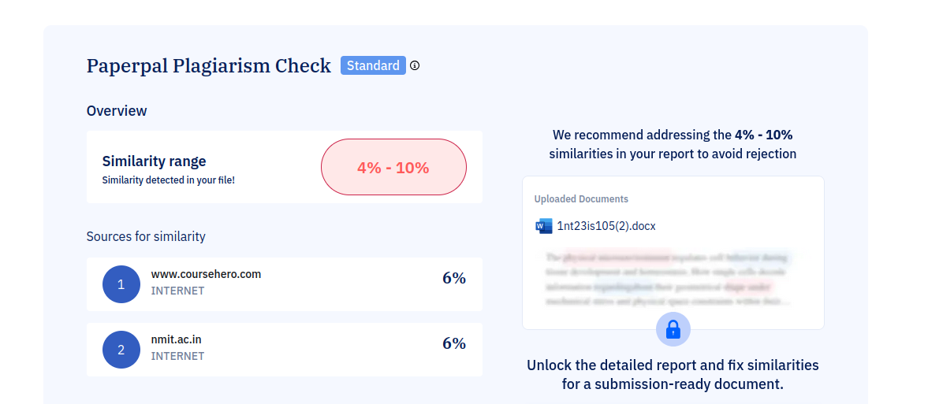Diagrams, charts, or tables should be used where relevant to clarify points, but they must be accompanied by appropriate explanations.